**Axis Aura CC**

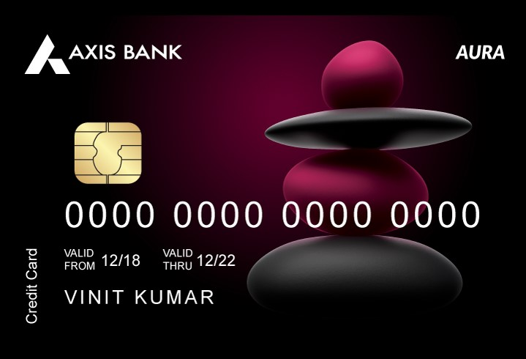

**Card Benefits**  
1. Get Decathlon & Amazon voucher of INR 750 as part of credit card welcome benefit. The voucher can be used at any Decathlon store or for online purchase as well. For details , visit: <https://www.axisbank.com/docs/default-source/default-document-library/decathlon-tnc.pdf>

2. Get 4 Free Video Doctor Consultation per month via Practo. Login at <https://axisbankaura.poshvine.com/> to avail benefit. For T&Cs, visit <https://www.axisbank.com/docs/default-source/default-document-library/video-consultation-practo-tnc.pdf>

3. Free 4 interactive video fitness sessions free per month via Fitternity . Get access to 16 recorded sessions per month. Login at <https://axisbankaura.poshvine.com/> to avail benefit. Select session time, date, type and book.

4. Discount annual discount of upto INR 500 on health checkup. Login at <https://axisbankaura.poshvine.com/> to avail benefit. For T&Cs , visit : <https://www.axisbank.com/docs/default-source/default-document-library/ihp-tnc.pdf>

5. Free yourself from paying fuel surcharge of 1% at any fuel station in India on spend of INR 400 – INR 4000 per month to avail the offer. Max. benefit per statement cycle is INR 250. GST charged on fuel surcharge is non-refundable.

6. Get min. 30% discount on nutritional /diet consultation from renowned nutritionists. Also get min, 30% discount on nutritional food.

7.  Earn Edge loyalty benefits

- Get 2 edge points on spend of INR 200 spent with your credit card. For more options to redeem your points, check the EDGE loyalty rewards catalogue.

8. Accelerated Edge Points for Insurance spends – Get 5X Edge reward points on insurance spends via Axis Aura card. Max. transaction amount is INR 1000.

9. Spend securely with an EMV certified chip . All credit card transactions are chip and PIN enabled for your protection. It reduces the possibility of counterfeit and skimming frauds.

10. Dining delights : get 20% discount at our partner restaurants in India. Updated list of partner restaurants.

**Fees & Charges**

|  |  |
| --- | --- |
| **Description** | **Charges** |
| Joining Fee | INR 749 |
| Annual fee | 2nd year onwards : INR 749 |
| Add on card joining fee | Nil |
| Add on card annual fee | Nil |
| Card replacement fee (lost or stolen or re-issue) | Nil |
| Interest charges | 3.6% per month |
| Cash withdrawal charges | 2.5% (Min. Rs. 500) of the cash amount |

**Eligibility criteria:**

* Employment status: Salaried or self-employed
* Income: Rs 50,000 per month (Salaried)
* Rs 60,000 per month (self-employed)
* Required Age: 21-65 years
* Applicant should be resident of India

**Documents required for the application**

* ID Proof
* Address Proof
* Income Proof
* PAN Card
* Coloured Photographs